Requirements/

**Capture Small Container Compactors**

Revision History

|  |  |  |  |
| --- | --- | --- | --- |
| **Date** | **Revision** | **Description** | **Author** |
| 10/15/2014 | 1.0 | Initial Version with Requirements | John Palubinskas |
| 11/2/2014 | 1.1 | Incorporated feedback from rev 1.0 review | John Palubinskas |
| 12/15/2014 | 1.2 | Incorporated feedback from rev 1.1 review and added screen shots | Roger |
| 2/9/2015 | 1.3 | Added design updates beased on findings from development | Roger |
| 3/11/2015 | 1.4 | Changes to functional and technical requirements | Mike Boylan |

The information furnished herein by Republic Services Inc. is proprietary and confidential to Republic Services Inc. personnel and is not to be duplicated, published, or disclosed to any third party in whole or in part without permission from Republic Services, Inc.

© Copyright 2015, Republic Services Inc. - All rights reserved.

Table of contents

1 Business Requirements 4

1.1 Purpose of the Design Specification 4

1.1.1 Business Functional Requirements / Configuration 4

1.1.2 Technical Design Requirements 6

2 Assumptions 13

3 Technical Design 14

3.1 Referenced Documents 14

3.2 Process Flow and Mock Ups 14

3.3 Functional Logic 15

3.4 Data Sources & Mapping 15

3.5 InfoPro Interface 15

4 Report Changes 16

5 Small CoNTAINER COMPACTOR (R-ENGINE) IMPLEMENTATION……………………….13

6 Appendix 14

# Business Requirements

## Purpose of the Design Specification

This project will support separate pricing for small container compactors. Currently, compactor pricing is included in the base rate. After project completion, commercial compactors will be a separate line item with separate guardrails and separate margins. This project supports the ability to designate a compactor as either customer owned or rented. It also allows the user to adjust the price of compactor rental.

### Business Functional Requirements / Configuration

| **Business Functional Requirement** | **Notes** |
| --- | --- |
| Commercial container configuration must provide the ability to designate a compactor as customer owned and allow the input of a compactor value and installation charge if the compactor will be rented. | * Customer Owned Compactor determines if the compactor is rented or customer owned. * Compactor Asset Value is the cost to purchase the compactor. * Installation Cost Estimate includes the delivery and installation costs. |
| Two new items will be added to the line item grid for rented small container compactors; the monthly rental fee and the one time installation charge. | * The Compactor Rental line will include: Cost, Floor, Average, Target, Price, FRF, ERF, Total and Billing Method. * The Installation line will include Price, FRF, ERF, Total and Billing Method. |
| Compactor rental will be removed from the Base costs, fees and guardrails. Non-rental compactor costs will be included in Base. | * Compactor additional site time is included in the Base line item. * Container costs and compactor costs exclusive of additional site time are calculated separately. |
| Costs, fees and guardrails will be calculated for Rental. Costs and Fees will be added to Installation. | * Rental cost is based upon total compactor depreciation, total compactor maintenance and a portion of the container rental. * Margins for compactor rental are stored in a configuration table will be used to calculate all guardrails. * Existing FRF and ERF algorithms will be applied to Compactor Rental and Installation. |
| Rental rate will be added as a line item to the Detail View in Monthly Totals if a rented compactor is included as part of the service. | * The Compactor Rental line will display the Cost Price, Floor Price, Average Price and Proposed Price. |
| Existing line items must retain their original guardrails and line item split throughout the system. | * Any service marked as a new service will be subject to Small Container Compactor rules and any service that is not marked as a new functionality service will not be included in the new functionality rules and be processed as exists today. |
| Any service change or rate adjustment must retain the existing line item break down. If an existing service has compactor rental included in the base rate, it must stay in the base rate after a rate adjustment. | * No changes to the compactor settings exist in the current Service Change model and have not been scoped into this project. * The line item grid for Base will display the Qty, Description, Current, Adjustment, $/%, Total, Billing Method and Activity. * Rental will be included in the Base price and guardrails will be calculated with container margins. * The pricing screen will reflect the old line item breakdown regardless of whether or not the original quote was created with the new or old item breakdown. |
| The Approval Email must display the Compactor Asset Value and line items for Rental and Installation if a rented compactor is included in the service. | * The Compactor Asset Value input in configuration will be displayed under Container Details.. * The Compactor Rental line in Service Details will include Cost, Floor, Average, Target, Price, FRF, ERF, Total and Billing Method in Service Details. * The Installation line in Service Details will include Price, FRF, ERF, Total and Billing Method. |
| The Proposal must display the Compactor Asset Value and line items for Rental and Installation if a rented compactor is included in the service. | * The Compactor Asset Value input in the configuration will be displayed under Service Details. * The Compactor Rental Price will be displayed in Estimated Monthly Amount and under Service Detals. * The Installation Charge Subtotal will be displayed in One Time Charges. |
| The CSA must display the Compactor Asset Value and Installation Charges. | * The C flag will be set to ‘Y’ if a compactor is part of the service (existing). * The Compactor Asset Value will appear in the Comments section. * The Installation Charge will be displayed in the OTHER and RATE/UNIT columns. |
| The Finalize page must display the Total Compactor Asset Value if one exists. | * Display the Total Compactor Asset Value below the Comments section. |

### 

### Technical Design Requirements

| **Technical Design Requirement** | **Notes** |
| --- | --- |
| **Compactor Owned**, **Compactor Asset Value** and **Estimated Installation Charge** fields must be added to **Service Criteria** under **3) Select Service Offering**. **Compactor Owned** will only be visible when **Compactor** is checked. **Asset Value** and **Installation Cost Estimate** will only be available when **Compactor Owned** is not checked. | The following variables will be repurposed:   * **Compactor Owned** – customerOwnedCompactor – Check Box - Boolean * **Asset Value** – compactorValue – Text Box – Currency   The following variable is new:   * **Installation Cost Estimate** – installationCostEstimate_s – Text Box - Currency   A constraint will be added to only display **Compactor Owned**, **Asset Value** and **Installation Cost Estimate** when **Compactor** is checked.  A constraint will be added to hide **Asset Value** and **Installation Cost Estimate** when **Compactor Owned** is checked. |
| In the line item grid under 4) Provide Pricing two new lines: **Compactor Rental** and **Installation**, if the a rented compactor is included in the service. **Qty**, **Description**, **Cost**, **Floor**, **Average**, **Target**, **Price** (Editable), **FRF**, **ERF**, **Total** and **Billing Method** are displayed for **Compactor Rental**. **Qty**, **Description**, **Price** (Not Editable), **FRF**, **ERF**, **Total** and **Billing Method** are displayed for **Installation**. | Two new lines need to be added to the Parts Record Set in Configuration under Recommended Items:   * **Compactor Rental** – Description built as existing with the title set to Compactor Rental and Billing Method set as Per Month. * **Installation** – Description built as existing with the title set to Installation and the Billing Method set as Per Service.   The break out of the above items is conditional upon having has_compactor set to 1, is_compactor _owned set to 0. |
| Compactor rental costs are to be removed from the Base Monthly cost. Additional site time due to the compactor is still in Base. A Container Rental Factor is now applied to Base. | **Base Cost Calculation (new)**  **Base Cost Per Month** = Cost To Serve Per Month * (1 - Container Rental Factor)  **Cost To Serve Per Month** = Total Base Cost + Base ROI  **Total Base Cost** = Disposal Processing Cost + Disposal Trip Cost + Operating Cost + Base Asset Cost  **Base Asset Cost** = Container Depreciation + Truck Depreciation + (Container Maintenance per Lift * Lifts per Month -> *if the container is not customer owned | otherwise 0)*  **Container Depreciation** = Depreciation per Container * Container Factor * Quantity -> *if the container is not customer owned | otherwise 0*  **Base ROI** = Commission + (Truck Allocated Value + Working Capital + (Container Value * Quantity -> *if the container is not customer owned | otherwise 0)* * Floor ROI / 12)  **Container Rental Factor** = (((Container Value * Quantity -> *if the container is not customer owned | otherwise 0)*  * Floor ROI / 12) + Container Depreciation) / Cost To Serve Per Month  **Guardrails**  **Unadjusted Base Floor Price** = Base Cost to Per Month / (1 – Floor Margin)  **Unadjusted Base Average Price** = Base Floor Price * ( (1 – Floor Margin) / (1 – Average Margin))  **Unadjusted Base Target Price** = Base Floor Price * ( (1 – Floor Margin) / (1 – Target Margin))  **Notes:**  Depreciation per Container comes from the Parts table.  Container Factor comes from the industries table.  Container Maintenance per Lift comes from the divisionKPI table  Floor ROI comes from the miscConfigData table.  Margins come from the miscConfigData table. |
| Compactor Rental Costs are based on the value of the compactor. | **Compactor Rental Cost Calculation**  **Cost To Serve Compactor Per Month** = Compactor Rental Asset Cost + Compactor ROI  **Compactor Rental Asset Cost** = Compactor Depreciation + Compactor Maintenance  **Compactor Depreciation** = (Compactor Value / Compactor Life) * Quantity -> *if the compactor is not customer owned and a compactor is included in the service | otherwise 0*  **Compactor Maintenance** = (Compactor Value * Compactor Maintenenace Factor / 12) * Quantity -> *if the compactor is not customer owned and a compactor is included in the service | otherwise 0*  **Compactor ROI** = Compactor Value * Quantity * Floor ROI / 12  **Guardrails**  **Unadjusted Compactor Rental Floor Price** = Cost to Serve Compactor Per Month / (1 – Floor Margin)  **Unadjusted Compactor Rental Average Price** = Compactor Rental Floor Price * ( (1 – Floor Margin) / (1 – Average Margin))  **Unadjusted Compactor Rental Target Price** = Base Floor Price * ( (1 – Floor Margin) / (1 – Target Margin))  **Notes:**  Compactor Value comes from Compactor Asset Value (compactorValue); or if null defaults to the parts table.  Compactor Mainenance Factor comes from the Div_Sm_Cont_Factors table.  Compactor Life comes from the parts table.  Floor ROI comes from the miscConfigData table.  Margins come from the miscConfigData table. |
| A new line will be created under Monthly Totals Detail View for **Compactor Rental**. The following sums need to be calculate;  **Cost Price**  **Floor Price**  **Average Price**  **Target Price**  **Proposed Price**  Calculations for **FRF, ERF** and **Total Estimated Amount** will reflect the new line item. | Compactor Rental **Cost Price** (smallMonthlyTotalRentalFloor_quote)= sum of all **Cost** columns from Compactor Rental line items  Compactor Rental **Floor Price** (smallMonthlyTotalRentalFloor_quote) = sum of all **Floor** columns from Compactor Rental line items  Compactor Rental **Average Price** (SmallMonthlyTotalRentalTarget_quote) = sum of all **Average** columns from Compactor Rental line items  Compactor Rental **Target Price** (smallMonthlyTotalRentalStretch_quote) = sum of all **Target** columns from Compactor Rental line items  Compactor Rental **Proposed Price** (smallMonthlyTotalRentalProposed_quote) = sum of all **Price** columns from Compactor Rental line items  ERF **Cost Price** = ERF on sum of Base **Cost** + ERF on sum of Compactor Rental **Cost**  ERF **Floor Price** = ERF on sum of Base **Floor** + ERF on sum of Compactor Rental **Floor**  ERF **Average Price** = ERF on sum of Base **Average** + ERF on sum of Compactor Rental **Average**  ERF **Target Price** = ERF on sum of Base **Target** + ERF on sum of Compactor Rental **Target**  ERF **Proposed Price** = ERF on sum of Base **Price** + ERF on sum of Compactor Rental **Price**  FRF **Cost Price** = FRF on sum of Base **Cost** + FRF on sum of Compactor Rental **Cost**  FRF **Floor Price** = FRF on sum of Base **Floor** + FRF on sum of Compactor Rental **Floor**  FRF **Average Price** = FRF on sum of Base **Average** + FRF on sum of Compactor Rental **Average**  FRF **Target Price** = FRF on sum of Base **Target** + FRF on sum of Compactor Rental **Target**  FRF **Proposed Price** = FRF on sum of Base **Price**  + FRF on sum of Compactor Rental **Price**  **Total Estimated Amount** will remain the sum of each column. |
| Existing line items must retain their original guardrails and line item split throughout the system. | **Base Cost Calculation (old)**  **Cost to Serve Per Month** = Total Cost + ROI  **Total Cost** = Disposal Processing Cost + Disposal Trip Cost + Operating Cost + Asset Cost  **Asset Cost** = Container Depreciation + Compactor Depreciation + Compactor Maintenance + Truck Depreciation + (Container Maintenance per Lift * Lifts per Month -> *if the container is not customer owned | otherwise 0)*  **Container Depreciation** = Depreciation per Container * Container Factor * Quantity -> *if the container is not customer owned | otherwise 0*  **Compactor Depreciation** = (Compactor Value / Compactor Life) * Quantity -> *if the container is not customer owned and a compactor is included in the service | otherwise 0*  **Compactor Maintenance** = (Compactor Value * Compactor Maintenenace Factor / 12) * Quantity -> *if the container is not customer owned and a compactor is included in the service | otherwise 0*  **ROI** = Commission + (Truck Allocated Value + Working Capital + ( (Container Value + Compactor Value) * Quantity -> *if the container is not customer owned | otherwise 0)* * Floor ROI / 12)  **Guardrails**  **Unadjusted Base Floor Price** = Cost to Serve Per Month / (1 – Floor Margin)  **Unadjusted Base Average Price** = Base Floor Price * ( (1 – Floor Margin) / (1 – Average Margin))  **Unadjusted Base Target Price** = Base Floor Price * ( (1 – Floor Margin) / (1 – Target Margin))  **Notes:**  Compactor Value always comes from the parts table for existing services.  Compactor Mainenance Factor always comes from the Site_Char_Factors table for existing services.  Depreciation per Container comes from the Parts table.  Container Factor comes from the industries table.  Compactor Life comes from the parts table.  Container Maintenance per Lift comes from the divisionKPI table  Floor ROI comes from the miscConfigData table.  Margins come from the miscConfigData table. |
| Calculate all values in the Service Change Model using the logic for existing customers. | All values in the Service Change model will be calculated according to the formulas in **TDR-006** above regardless of how the existing service was broken down originally. |
| All line items, including **Compactor Rental**, must be included in the **Service Details** section of the approval email. Items displayed are:  **Service**  **Cost**  **Floor**  **Average**  **Target**  **Price**  **FRF**  **ERF**  **Total.**  **Compactor Asset Value** must be populated in **Container Details**. | Line items will be picked up by the lineItemGridforEmailTemplate function without additional effort.  The **Compactor Asset Value** (compactorValue) will be displayed for each service line. The default is “N/A”. |
| In the Proposal, under **Service Details**, **Compactor Rental Rate** and **Compactor Asset Value** must be displayed on each line item.  The category **Estimated Monthly Amount** must include the sum of rental prices unter **Small Container Compactor Rental Charge**.  The category **One Time Charges** needs to include the sum of **Installation Cost Estimate** in **Installation Charge Subtotal**. | The **Compactor Asset Value** (compactorValue) and **Compactor Rental Rate** (sellPrice_line for the Compactor Rental line) will be displayed in the right column of each line for **Service Details**.  The **Small Container Compactor Rental Charge** (smallMonthlyTotalRentalProposed_quote) is calculated for Monthly Totals.  The existing **Installation Charge Subtotal** (installationChargeSubTotal_quote) must be included under **One Time Charges**. |
| In the CSA, **Installation Cost Estimate** will be displayed in the line item grid in the **OTHER** and **RATE/UNIT** columns per container group. Compactor Asset Value will be displayed in **COMMENTS** by container group | Examples:  OTHER | RATE/UNIT  Installation | $975.00  COMMENTS  Compactor Asset Value for FL 8.00 yard - $5250.00 |
| The **Total Compactor Asset Value** field must be added under the **Comments** field for **7) Finalize Quote** if the customer has one or more rented compactors. | The following variable is new:  **Total Compactor Asset Value** – totalCompactorValue – Read Only Text - Float.  **Total Compactor Asset Value** = sum of **Compactor Asset Value** from all line items.  A constraint will be added to display **Total Compactor Asset Value** if the value is not 0. |
| Add and populate with .04 the **comp_maint_factor** fields to the **Div_Sm_Cont_Factors** table in the **SmallContainers** schema. | Table: **Div_Sm_Cont_Factors**  Name: **comp_maint_factor**  Description: Maintenance Percentage / 100 on small container compactors.  Type: Float  Default: .04 |
| InfoPro XML Integration | See section 3.5 for InfoPro Integration |
| Load new configuration template data into Capture | Compactor Maintenance Factor will be added to division placemats and defaulted to .04. It is changeable. |

# Assumptions

Other Assumptions

* Small Container Compactor rental pricing will follow the same model as Large Container Compactor.
* There are no Disposal charges to incorporate for Small Container Compactor.
* We may need to add a constraint for the Container Size to limit it to 6 or 8 yard sizes only for small container compactor (VIP.)
* There are no expected impacts on Large Container.
* If the Small Conatiner Compactor installation logic is created to revise the asset value based on a proposed installation price that is below cost, then Large Container Compactor logic should be modified to follow similar logic (a new requirement for Large Containers.)

# Technical Design

## Referenced Documents

None

## Process Flow and Mock Ups

Use current container process flow and logic for large containers

An example of the current line item grid for new/new business. In this case new lines for Rental and Installation would need to be added for the small container with a compactor.

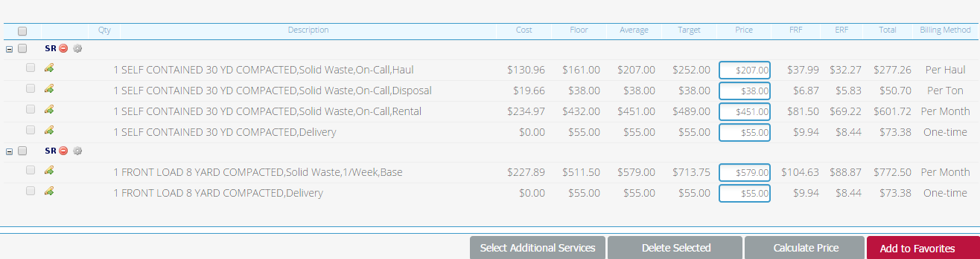

On proposal for the above new/new example add Container Rental

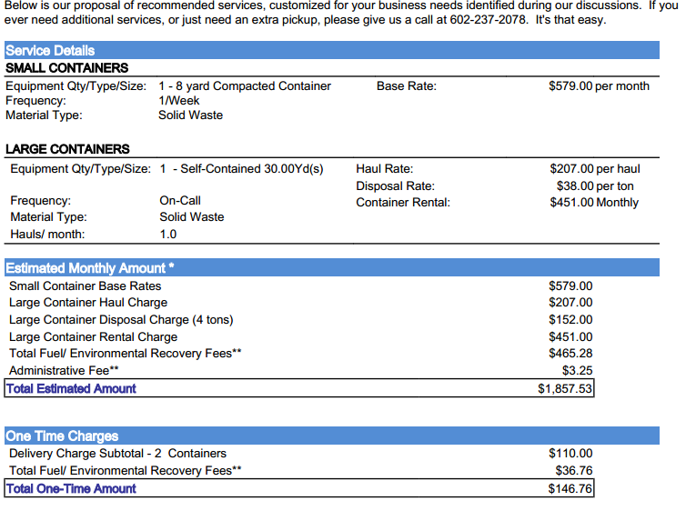

Add one time installation charges here. DEL charges will be part of the container delivery

Compactor Rental $99.99 per month

Add installation charge here.

Asset value here in Office Use CSA only.

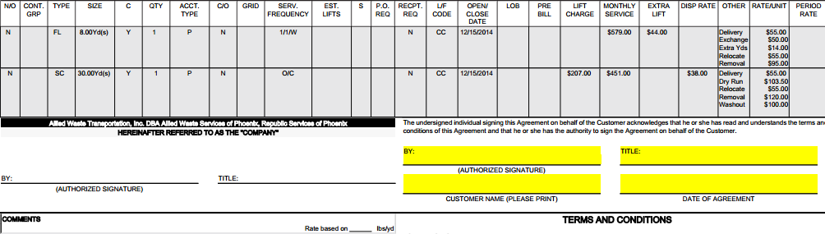

Existing Large or Small

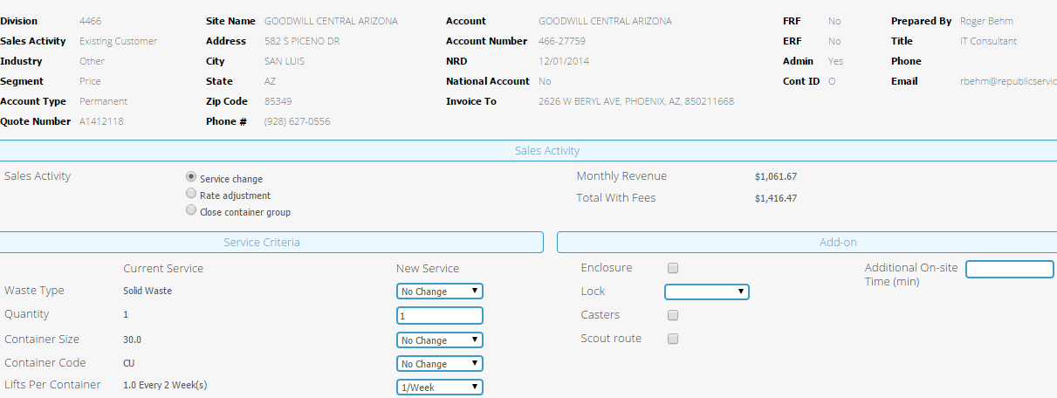

Add “Asset Value” field here.

## Functional Logic

Use current container functional and pricing logic

## Data Sources & Mapping

For detailed mapping information, please refer to the BMI [Enterprise Mapping Document](http://itpmo-2013projects/Pricing%20Initiative/2.0%20Planning%20and%20Requirements/BMI%20Enterprise%20Mapping%20Document.xlsx).

## InfoPro Interface

These are the new or modified fields that may affect the AAE process. All testing around the InfoPro Upload should center around the items below.

**CONFIG**

REPURPOSED

* Asset Value – compactorValue – Currency - asset value of the compactor, this is common to both large and small compactor now
* Customer Owned Compactor – customerOwnedCompactor – Boolean – flag that determines whether or not the compactor is customer owned, this is common to both large and small compactor now

NEW

* Estimated Installation Charge –estimatedInstallationCharge – Currency – was specified with a different caption from large container installation and applies to both delivery and installation of the compactor for a small container.

**COMMERCE**

NEW

* Small Monthly Total Base Floor - smallMonthlyTotalBaseFloor_quote – Currency – sum of cost of servicing all small containers only,  this will be populated by the small monthly total floor for existing services
* Small Monthly Total Base Base - smallMonthlyTotalBaseBase_quote – Currency – sum of floor guardrails for servicing small containers only, this will be populated by the small monthly total base for existing services
* Small Monthly Total Base Target - smallMonthlyTotalBaseTarget_quote – Currency – sum of average guardrails for servicing small containers only, this will be populated by the small monthly total target for existing services.
* Small Monthly Total Base Stretch - smallMonthlyTotalBaseStretch_quote – Currency – sum of target guardrails for servicing small containers only, this will be populated by the small monthly total stretch for existing services.
* Small Total Base Current Price - smallTotalBaseCurrentPrice_quote – Currency – for existing customers, the total current monthly charge for servicing small containers only., this will be populated by the small total current price for existing services.
* Small Monthly Total Base Proposed - smallMonthlyTotalBaseProposed_quote – Currency - the proposed total monthly charge for servicing small containers only.
* Small Base Change In Price - smallBaseChangeInPrice_quote – Currency – the difference between the current and proposed price for servicing small containers only.
* Small Monthly Total Rental Floor - smallMonthlyTotalRentalFloor_quote – Currency – the cost of servicing all compactors for small containers
* Small Monthly Total Rental Base - smallMonthlyTotalRentalBase_quote – Currency – the sum of floor guardrails for renting compactors on small containers
* Small Monthly Total Rental Target - SmallMonthlyTotalRentalTarget_quote – Currency – the sum of average guardrails for renting compactors on small containers
* Small Monthly Total Rental Stretch - smallMonthlyTotalRentalStretch_quote – Currency – the sum of target guardrails for renting compactors on small containers
* Small Total Rental Current Price - smallTotalRentalCurrentPrice_quote – Currency - for existing customers, the total current monthly rent for compactors on small containers
* Small Monthly Total Rental Proposed - smallMonthlyTotalRentalProposed_quote – Currency - the proposed total monthly rent for compactors on small containers.
* Small Rental Change in Price - smallRentalChangeInPrice_quote – Currency - the difference between the current and proposed rent for compactors on small containers.
* Small Monthly Base Price Including Fees - smallMonthlyBasePriceInclFees_quote – Currency – the total monthly sell price for all small containers.
* Small Monthly Rental Price Including Fees - smallMonthlyRentalPriceInclFees_quote – Currency – the total monthly container rental price for compactors on small containers.

# Report Changes

No Changes

**5. Small Container Compactor (R-Engine) implementation**

*Working logic of R-Engine for small container before compactor implementation:*

The function COM_pricing in R is responsible for the pricing of small container (New or Existing). The most important assumption in this working logic is that the container and compactor are considered a single unit i.e. if a customer’s “has_compactor” flag is true then everything which is true for the container is also true for the compactor, such as, customer owned or not and all the cost is included in the calculations with the container itself. In this function for small containers the cost assets and ROI costs are calculated for container and compactor together since they are considered as a single unit. Hence, applying all the adjustments such as industry_adj, segment_adj etc. and margins on the total cost_to_serve for container and compactor together.

Cost Assets = Container Depreciation + Compactor Depreciation + Compactor Maintenance + Truck Depreciation + Container Maintenance per Month

ROI Cost = ((Truck Allocation + Container Cost + Compactor Cost + Working Capital) *0.065/12) + Commission

Cost To Serve = Disposal Processing Cost + Disposal Trip Cost + Site Time Cost + Cost Assets + ROI Cost

This provides per month line item which includes container and compactor both.

*Working logic of R-Engine for small container after compactor implementation:*

In this Implementation we get rid of the most important assumption which is that the container and compactor are a single unit i.e. if “has_compactor” flag is true then the container is mutually exclusive of the compactor. Hence, in this implementation we calculate cost assets and ROI costs for container and compactor separately and then cost assets and ROI costs for compactor along with container depreciation and container cost will make rental line item and remaining cost assets and ROI costs will make monthly line item. Also, all the adjustments are applied only to the container cost to serve and not on the compactor cost to serve along with FRF and ERF premiums are applied on the total cost to serve of both container and compactor but added to only container prices. Compactor has its own static margins applied to compactor cost to serve, which are different than the margins applied to the container cost to serve. The Compactor Cost, Compactor Depreciation and Compactor Maintenance is effected by if the customer has a compactor and if it is customer owned.

Compactor Depreciation and Maintenance = (Compactor Depreciation + Compactor Maintenance) * Quantity*(1-Compactor Owned)*has_compactor

Compactor Cost = Compactor Cost*Quantity*(1-Compactor Owned)*has_compactor

Cost Assets of container = Container Depreciation + Truck Depreciation + Container Maintenance per Month

Cost Assets of compactor = Compactor Depreciation + Compactor Maintenance

ROI Cost of container = ((Truck Allocation + Container Cost + Working Capital) *0.065/12) + Commission

ROI Cost of compactor = Compactor Cost * 0.065/12

Cost To Serve of container = Disposal Processing Cost + Disposal Trip Cost + Site Time Cost + Cost Assets of container + ROI Cost of container

Cost To Serve of compactor = Cost Assets of compactor + ROI Cost of compactor

The Parts table used to pull values of Compactor Cost, Compactor Life, Compactor Depreciation and Compactor Additional Site Time is “tbl_parts_mod”.

This will give 2 line items: Monthly and Rental.

# 6 Appendix